Exercise 11. Separation of Amino Acids by Ion Exchange Chromatography

OBJECTIVES
In this experiment we will separate a mixture of three amino acids on a strong acid ion-exchange resin. The amino acids are separated by elution with sodium citrate buffer and they are displaced as a function of their pI values by changing the pH of the buffer solution. The effluent from the column is collected and analyzed for amino acid content.

Prelab Questions:

- Consider a protein with the following amino acid composition: 3 R, 6 E, 2 H, 4 A, and 9 K. If you were to purify this protein using cation exchange, at what pH would you equilibrate and load your column? How will the elution buffer differ from the loading buffer?
- In addition to cation exchange, we want to purify this protein using hydrophobic interaction chromatography. Should we do this before or after cation exchange? Why?
- In this lab, we are quantifying amino acid content using ninhydrin. Why are we using this instead of the Bradford / BioRad reagent used in the previous lab. Explain.

BACKGROUND
Ion exchange chromatography is based on the association of charged groups in a liquid that passes over a solid support or ion exchange resin. The resin is an insoluble matrix, usually polystyrene, to which charged groups are covalently bound. Positively charged ion-exchange resins have negative ions associated with them - hence they are called anion exchangers. Similarly, cations are reversibly bound to resins with negatively charged groups and are called cation exchangers. Amino acids at pHs below their isoelectric point are positively charged and will bind to a cation exchange resin.
There are two general classes of cation exchange resins:

1. Weakly acidic exchangers containing carboxylic acid exchange groups (-COO⁻). Two common types are BioRad BioRex 70 and Rohm & Haas IRC-50. Weak resins have pK_{a} values below the pI of many amino acids and so the resin is not significantly charged at pH values above the pK_{a} of the resin. There will only be weak binding of amino acids to the resin in the range pK_{a} < pH < pI_{amino acid}.
2. Strongly acidic exchangers composed of sulphonic acid functional groups (-SO₃⁻). BioRad offers a a sulphonic acid resin attached to a styrene divinylbenzene resin (AG 50W) and Rohm & Haas markets Dowex 50 and IR-120. The size of the resin beads varies with the manufacturer.

As amino acids move down an ion-exchange column they displace the counterion of the charged resin and the relative binding is a function of the extent of ionization of the amino acid and other factors such as hydrophobic interactions between the amino acid and the resin. The resin is initially regenerated so that it is in the sodium form. This is usually accomplished by a wash with NaOH, which displaces any residual bound material.

Amino Acid Determination
The amino acid concentration of the effluent fractions are determined by the addition of a buffered ninhydrin solution containing some reduced ninhydrin (hydrindantin) which prevents interference from oxygen. The yield of blue color in the reaction of ninhydrin with amino acids is nearly quantitative if the reaction is allowed to run 20 minutes or more at elevated temperatures. Because buffer changes must be made during interludes between peaks, the ninhydrin reaction must be run on the fractions as soon as they are collected. It is not necessary to wait the full 20 to 30 minutes to see if the fraction contains amino acids.
The ninhydrin reaction involves the formation of a colored species, Ruhemann’s purple, by the decarboxylative deamination of all the amino acids but proline (why?). The intermediate iminium ion is hydrolyzed to form an amine that condenses with a second molecule of ninhydrin.
The reaction is illustrated below.

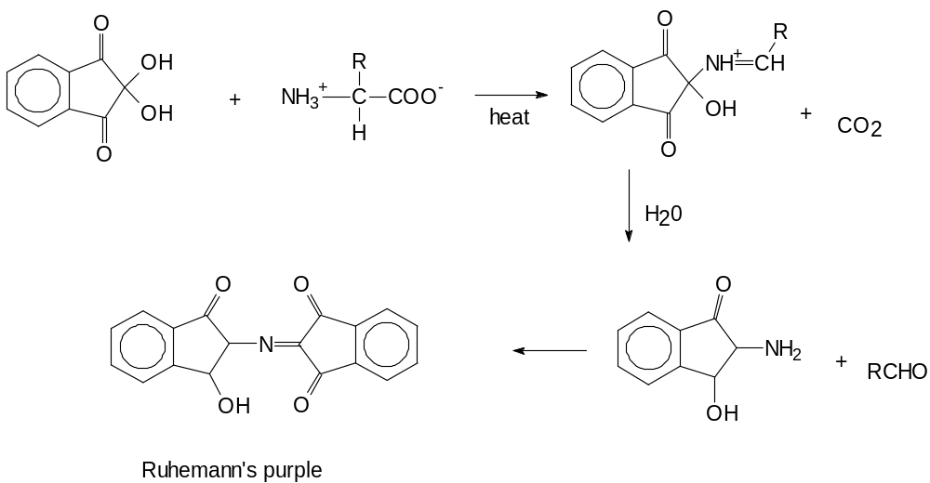

PROCEDURES: This lab is split over two lab periods.

Column Preparation: Day 1
1. Support a 1x15 cm Econo-Column on a ring stand and attach a 3-way plastic stopcock to the bottom.

2. Pour in 6 ml of water and mark the level to which it fills the column. Pour the water out and slowly introduce enough Dowex 50 (100-200 mesh), suspended in 0.04M sodium citrate buffer, pH 2.8, to fill the column to the 6-ml mark. The resin is in a slurry of ~50% solids. Swirl the mixture to suspend the beads, then pipet a few mls of the suspension into the column. Allow the resin to settle, and repeat until the resin level is at ~6-ml. Record the actual level of the resin in your notebook.

3. Slowly pour about 1-2 ml of sea sand on top of the resin in the column. The sand will prevent the resin from being disturbed by the elution buffers.

4. Attach a piece of the supplied hose to the end of the stopcock; this will facilitate manual collection of the drops into tubes. Open the stopcock and allow 15 ml of 0.04M sodium citrate buffer, pH 2.8 to pass through to equilibrate the resin.

Application of Sample

5. You will be provided with ~5 ml of a solution containing a mixture of L-aspartic acid, L-tyrosine, and L-arginine, in 0.04M sodium citrate buffer, pH 2.8 (sample 1). You will be provided a second solution (~5ml) containing an unknown amino acid (sample 2). Set aside 0.5 ml of each solution for total amino acid content determination before applying the remainder of the sample to the column.

6. Allow the liquid above the resin to drain through the column until the level reaches the top of the column, then shut the stopcock. Carefully add exactly 4.0 ml of the sample 1 solution to the top of the column, being careful not to disturb the top of the resin. Allow the sample to pass into the resin and collect the first 4 ml of breakthrough effluent. Do not allow the column to run dry at any point.

7. Shut the stopcock and wash the wall of the column with 2.0 ml of the pH 2.8 citrate buffer. Collect the effluent for a total of 6.0 ml of breakthrough effluent and designate it “Fraction 1.”

Elution of Amino Acids

8. The following buffers are used sequentially to elute the amino acids from the column, one at a time. They must be used in the correct order or the experiment will fail.

1. 0.08M Na Citrate, pH 3.4 (48 ml)
2. 0.10M Na Citrate, pH 4.8 (60 ml)
3. 0.40M Na Citrate, pH 7.0 (60 ml)

When the amino acid solution and wash have passed completely into the column, close the stopcock and carefully add 3 ml of the first buffer (pH 3.4) to the top of the column. Add the buffer slowly, against the sides of the column walls so that the sand will not be disturbed so much as to affect the resin underneath.

9. Collect fractions of 3.0 ml, allowing gravity to cause the flow-through. (The column operates at steady such that the same volume of liquid added to the top will elute from the column.) When one fraction has been collected, switch the tubing attached to the column to the next fraction and add additional buffer. Make sure that the tubing lies above the liquid level in each fraction. Measure the average flow rate of the column.

- Once the first buffer has completely passed into the column, shut the stopcock, add several ml of the second buffer, attach the reservoir containing the new buffer, and continue the elution as before. This procedure is continued until the elution is completed. Record the relation between the fraction number and the identity of the elution buffer.

- Repeat steps 4-12 using sample 2.

- Once the column is completed, store your samples in the refrigerator.

Quantification of Column Fractions: Day 2

11. Perform the ninhydrin reaction on all of the fractions after they have all been collected. Add 1.0 ml of the effluent from the ion exchange column to 0.5 ml of the ninhydrin reagent. No adjustment of pH is necessary. Cap, and shake by hand (wear gloves or you’ll stain your hands/clothes/etc.). Heat for 15 minutes in a boiling water bath. An entire rack of tubes can be heated at one time. The absorbance of each tube should be read at 570 nm against a blank made by performing the ninhydrin reaction on the appropriate buffer containing no amino acids.

12. Add the 0.5 ml of the original sample saved from earlier in the experiment to 0.5 ml of 0.04M Na Citrate buffer pH 2.8 to bring the volume up to 1.0 ml. Then add 0.5 ml of the ninhydrin reagent use the same procedure as described above.

Guidelines for Analysis & Conclusions Section
(Remember, these are points you should consider and include in your analysis. This section, however, need not be limited to these specific guidelines.)

1. Prepare a plot of absorbance versus elution volume. Care must be taken to identify overlapping peaks since the amino acids are identified by their relative order of retention on the column. Identify the unknown amino acid in sample 2 based on the elution profile you obtain and your known standards from sample 1.

2. In what order will the following amino acids be eluted from a column of Dowex 1 ion exchange resin by a buffer at pH 6: arginine, tryptophan, aspartic acid, histidine, and leucine? What is the expected order using Dowex 50 at the same pH? Is the order affected if one uses a phospho-cellulose resin? If so, how and why?

3. In what order will the following proteins be eluted from a CM-cellulose ion exchange column by an increasing salt gradient at pH 7: lysozyme, ribonuclease A, insulin, collagen, hemoglobin, and ovalbumin?

Protein | Isoelectric pH
Ovalbumin (hen) | 4.6
Insulin (bovine) | 5.4
Collagen | 6.6
Hemoglobin (human) | 7.1
Ribonuclease A (bovine) | 7.8
Lysozyme (hen) | 11.0

4. Use the triangular method as described on pg. 512 of Blanch and Clark to draw triangles for your three elution peaks so that you can determine the average retention time, the base line peak width, and the standard deviation for each peak. Estimate the length of packing in your column (L). Use this to find the cross sectional area of the column (A) from the volume of packing that you used. Since you know an estimate of the flow rate through the column (q), calculate the solvent residence time t₀ = L*A/q. Now you can determine the retention factors for each of the three amino acids (pg. 530, eq 6.127). Use eq 6.113 on pg. 527 to determine a height of a theoretical plate (H) for each peak. Use eq 6.105 to find the theoretical plate number for each. Finally use eq 6.130 on pg. 530 to find the resolutions between each of the peaks. Note that the separation factor is a ratio of retention factors.

EQUIPMENT AND REAGENTS
Dowex-50W, 8% cross-linked, 100-200 mesh (80ml)
400gm of commercial resin (Bio-Rad) is stirred with 8L of dH₂O in a glass jar for 5 minutes and then allowed to settle for 20 minutes. The supernatant solution, containing fine particles of resin, is decanted and discarded. The washing and settling is repeated twice to remove all fine particles that might clog a column. The resin is then suspended in 4L of 4% (w/v) NaOH, allowed to settle, and the supernatant solution is decanted. The resin is then washed twice in the same way with 4L of dH₂O. Finally, the resin is suspended in 2L of 0.04M sodium citrate buffer, pH 2.8; it is stirred with this buffer for 30 minutes, allowed to settle, and the supernatant solution is decanted. The equilibration and washing with citrate buffer, pH 2.8, is repeated once, and the final prep is stored in a closed bottle at 0-5∞C until needed. This is enough resin for 15-20 columns – scale as necessary

Solution of 3 amino acids (5 ml per student)
Stock solutions of aspartic acid, tyrosine, and arginine are prepared in 0.04M sodium citrate, pH 2.8. The exact final concentration of each amino acid is left to the discretion of the T.A. Unknown solutions should contain 0.5-2.0 mg of each amino acid.

Sodium citrate buffer, 0.04M, pH 2.8 (500ml)
Sodium citrate buffer, 0.08M, pH 3.4 (500ml)
Sodium citrate buffer, 0.10M, pH 4.8 (500ml)
Sodium citrate buffer, 0.40M, pH 7.0 (500ml)
(Prepare buffers by titrating citric acid to the desired pH with NaOH. Do not back-titrate sodium citrate with HCl.)
NaOH, 10% (w/v) (100ml)

Ninhydrin Reagents
A stock solution of ninhydrin reagent is prepared from 2 gm of ninhydrin and 0.3 gm of hydrindantin in 75 ml of 2 methoxyethanol followed by dilution with 25 ml of 4N sodium acetate (pH 5.5). The resulting red solution is stored under nitrogen in the dark. For long term storage, the bottle should be equipped with a nitrogen siphon.

Econocolumn (1 x 15 cm) with top and 3-way stopcock
Extension tubing
Rulers
Sterile Falcon tubes
Boiling water bath

REFERENCES

Blanch, H.W., and Clark, D.S. (1988) Biochemical Engineering, pp. 6-38 to 6-66.
Cantor, C.R., and Schimmel, P.R. (1980) Biophysical Chemistry, Part I, pp. 41-53, W.H. Freeman and Company, San Francisco.
Voet, D., and Voet, J.G. (1990) Biochemistry, pp. 82-85, John Wiley and Sons, New York.

